**From:** Huxley Rust **Date:** 02/23/2025 **Subject:** Laplace Transform Analysis of an RC Circuit with an AC Excitation

**Introduction:** In this lab we used an AC function in an RC circuit to visualize how Python can be used to visualize the frequency response (both magnitude and phase change) of a Laplace equation derived from the given circuit.

**Circuit Analysis and Calculations:**

|  |  |  |
| --- | --- | --- |
|  | **2.2kΩ resistor** | **Vo1 Capacitor** |
| **Expected** | 2200 Ω | 0.01 µF |
| **Measured** | 2156 Ω | 0.0103 µF |
| **%Error** | 2.00% | 3.00% |

* **Fourier Analysis:** The Fourier analysis of the circuit vastly simplifies the process of solving these problems because instead of doing a bunch of calculations integrals and differentiations and extracting equations from the circuit at hand we are able to create a simplified set of algebraic equations that would then allow us to calculate the frequency response (including both magnitude and phase) of the circuit we are using. For more information watch this video -> <https://www.youtube.com/watch?v=65yw9klPklk>. In short, however, you can solve the circuit using differential equations like this:

$$V_{in}\left(t\right)= V_{R}\left(t\right)+V_{C}\left(t\right)=2sin⁡(ω⋅t)$$

$$V_{R}\left(t\right)=I⋅R=V_{o}(t)$$

$$V_{C}\left(t\right)= V_{in}\left(t\right)- V_{R}(t)$$

$$\frac{V_{R}\left(t\right)}{R}= C\frac{d}{dt}[V_{in}\left(t\right)- V_{R}\left(t\right)]$$

$$\frac{V_{out}\left(t\right)}{RC}+\frac{d}{dt}[V_{out}\left(t\right)]= 2ω⋅sin⁡(ω⋅t)$$

And then you can continue separating equations like we did at the beginning of the semester, guessing solutions, multiplying by 1/sqrt(2) and then finding the same thing that you would get if you had just solved for Vout using Laplace. Which in this case because it is simply just a RC circuit you would find that attenuation of the output signal would occur at

$$ω_{C}= \frac{1}{RC}$$

**Experimental Procedure and Results:**

* **Setup Description:** Our function generator was set to output a 2 Vpp sinusoidal voltage. We swept the frequencies on the function generator from 100 Hz to 200 kHz to observe the magnitude and phase shift on our oscilloscope.
* **Cutoff Frequency:** The experimental cutoff frequency was determined by looking at where the the voltage dropped to a factor of 1/sqrt(2) of the initial voltage value. We found that this happened in our circuit at around 7400 Hz – 7800 Hz. Compared to the theoretical (calculated) cut off frequency of 7167 Hz our percent error was roughly 3.15% - 8.12%. The lack of uncertainty here is because the voltage measurements on the oscilloscopes were only registering changes of voltage as small as 0.04 V which in our case lands us with a %Error range of about 5%.
* **Waveform Plots:**

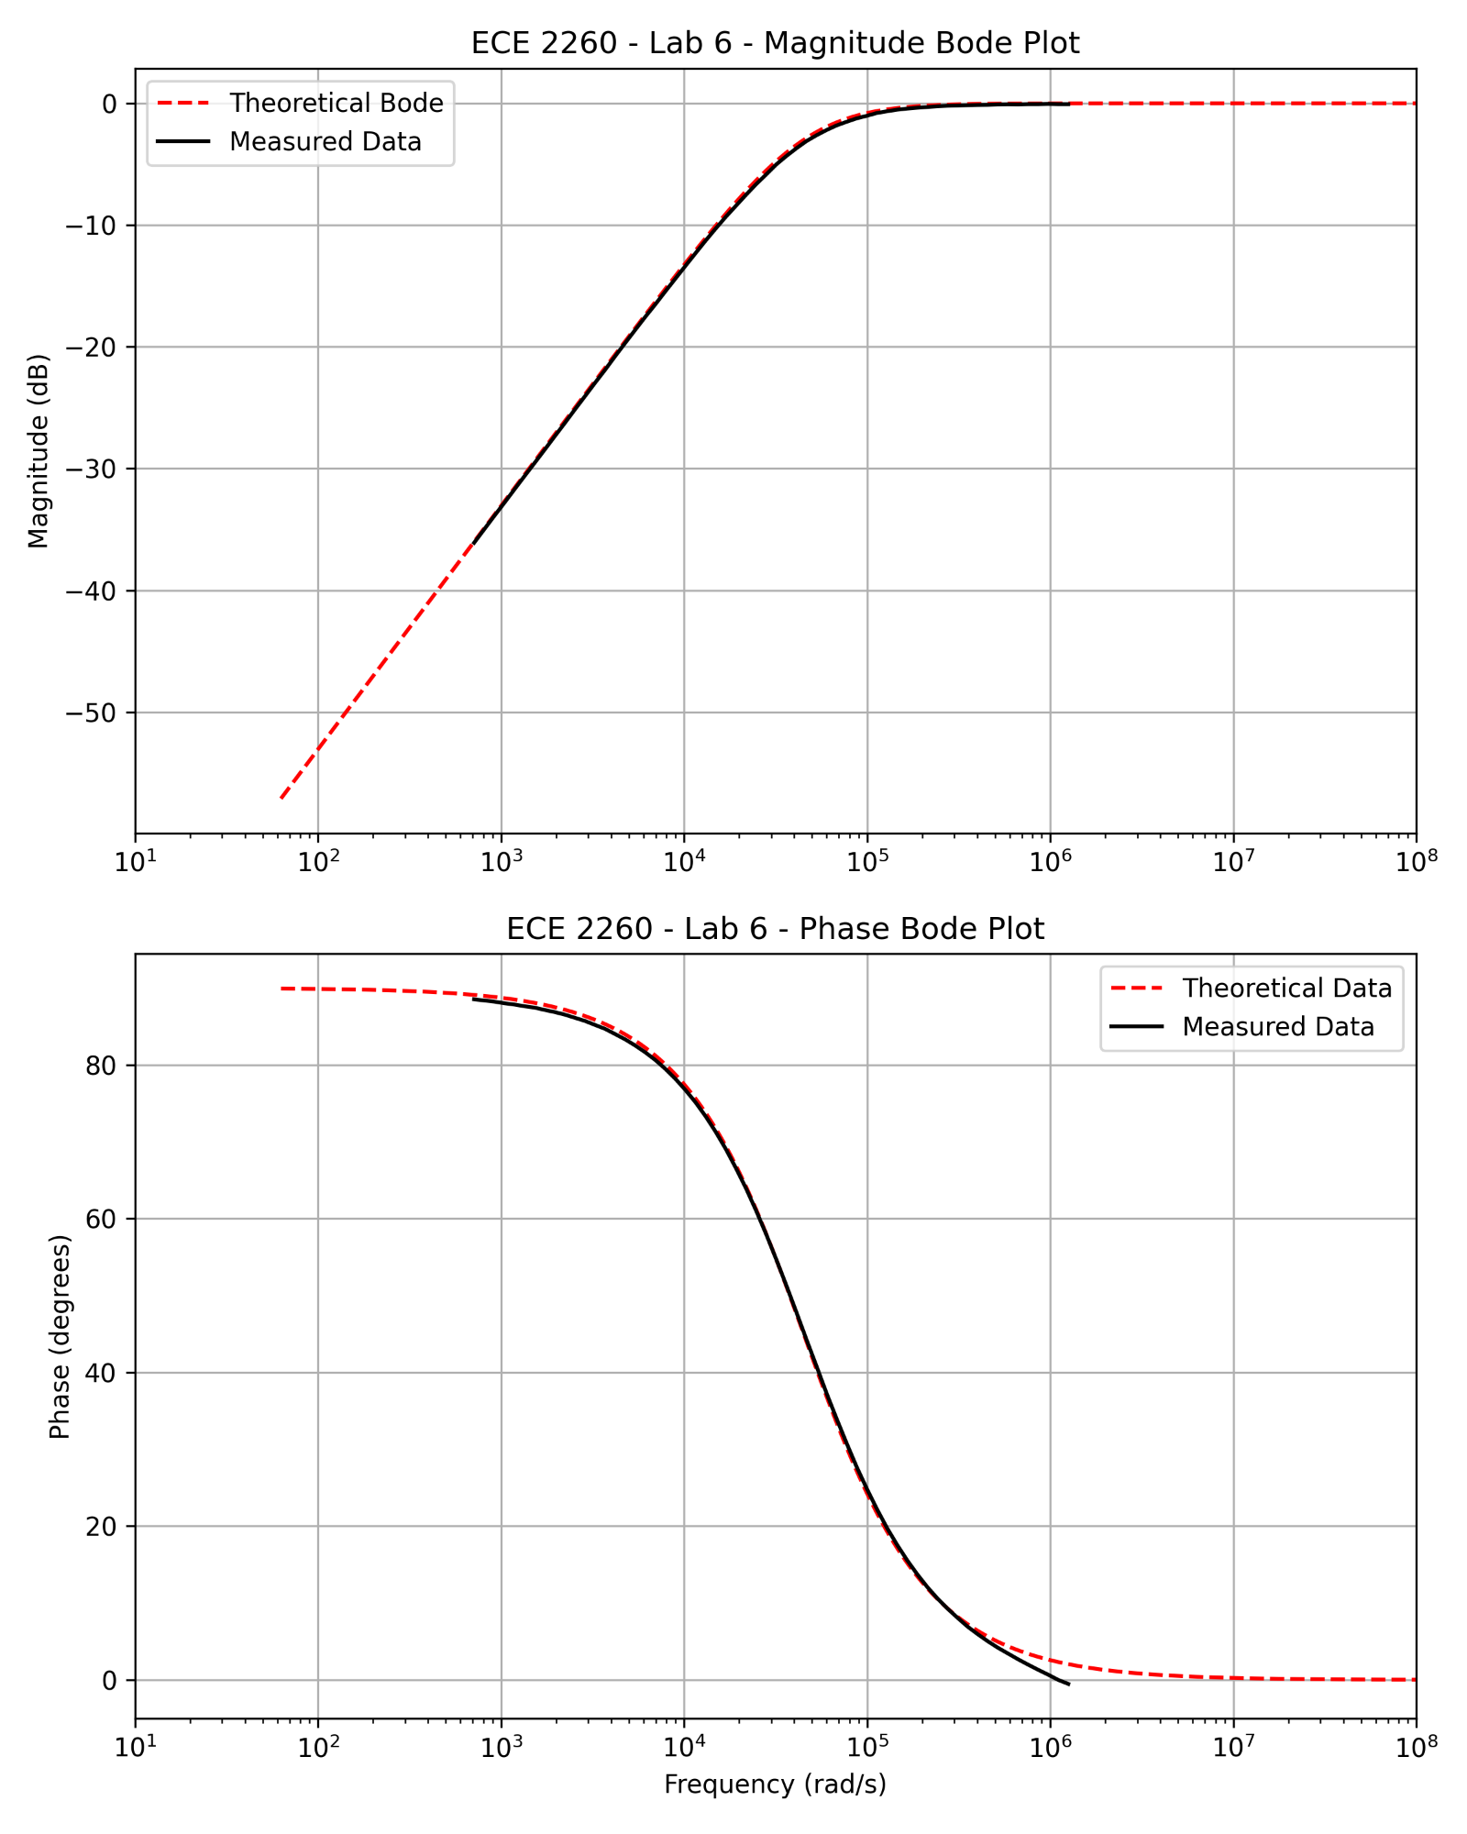

* **Quantitative Comparisons:** Our theoretical magnitude and phase match very well. The only discrepancy is that the leading and the tail end of the phase curves are off by a small amount, but this could be a result of the oscilloscope’s in-exact measurement of the data as well as the components’ in-exact resistor and capacitor values.

**Additional Discussion Questions (5, 6, 7):**

1. Python is an extremely easy and time efficient way to quickly visualize the expected magnitude and phase output of a given circuit. If you were to only rely on plotting the magnitude and the phase of a circuit by hand you would not only have to spend a much more substantial amount of time getting a much lower quality graph, but you would also have the potential to make mistakes whilst doing it. It is much better to let a computer do the menial task while you go to lunch or take a nap.
2. If you were to increase either the value of R or C in the circuit your cutoff frequency would decrease. This would result in your gain decreasing quicker as well as a quicker shifting in phase as you increase the frequency of your voltage source. As we discussed earlier the cutoff frequency for this circuit is

$$ω_{C}= \frac{1}{RC}$$

Therefore, increasing either the R or the C value will change where the circuit begins to attenuate the signal. This is important based upon where you would like to keep certain input frequencies in or make sure that they are not amplified along with the rest of the signals that you think are important.

1. If we had an RLC circuit, we would be able to extend our analysis to a Band-pass filter or a Band-stop filter. In these circuits we would be able to amplify a specific range of frequencies or cancel out a specific range of frequencies. The transfer function itself would become something like

$$H\left(jω\right)= \frac{(\frac{R}{L})⋅jω}{{(jω)}^{2}+ \left(\frac{R}{L}\right)⋅jω+\frac{1}{LC}}$$

**Conclusion:**

In this lab we found how and RC circuit (and subsequent output magnitude and phase) response to a given AC voltage input. We also learned how a signal can either be attenuated or amplified depending on what a circuit designer is looking for in an output. One very important place I can see this being useful is for audio engineers trying to amplify certain frequencies and attenuate others in search of a specific output they would like to hear.